BENCHMARK OF ALGORTHMS

By
Troy Samra,
Majid Farhadloo

A report detailing the run times of common sorting algorithms
and theoretical analysis of the results.

CSCI 115 – Algorithms and Data Structures

Department of Computer Science
California State University Fresno
05 March 2018

ABSTRACT

In this project five different sorting algorithms were tested sorting different types of arrays and their speed was recorded and analyzed for academic purposes. Insertion sort, Selection sort, Bubble sort, Quick sort, and Merge sort were all tested on sorted, random, reverse, and 10% shuffled arrays. Moreover, each sort was run on different size arrays ranging from 10 to 1,000,000. Each sorting algorithm was found to have strength and weaknesses but in general it was discovered that Bubble sort had the worst performance and Merge sort the best. Insertion sort and Selection sort were found to be similar with respect to speed, but Insertion sort seemed to be quicker on average in testing. Quick sort and Merge sort were found to also be similar but like Insertion sort, Merge sort seemed to be faster on average. In conclusion, the testing of all the algorithms on each type of array showed that overall Merge sort is the fastest and this would explain why it is used widely by professionals in Industry.

TABLE OF CONTENTS

ABSTRACT…………………………………………………………………………………….…2
LIST OF FIGURES………………..………………………………………………………….…..4
INTRODUCTION…………………………………………………………………………..…….5
METHODS…………………………………………………………………………………..……5
RESULTS AND DISCUSSION…………………………………………………………………..7
Insertion sort……………………..…………………………………………………………….7
Selection sort…………………………………………………………………………….….….8
Bubble sort……………………………………………………………………………………..9
Quick sort……………………………………………………………………………….…..….9
Merge sort……………………………………………………………………………...……..10
CONCLUSION.......................................................................................................................…...11
REFERENCES…………………………………………………………………..………………12

LIST OF FIGURES

Figure 1 Insertion sort run time analysis…………………………………………………………..8
Figure 2 Selection sort run time analysis…………………………………………………...……..8
Figure 3 Bubble sort run time analysis……………………………………………………………9
Figure 4 Quick sort run time analysis……………………………………………………...…….10
Figure 5 Merge sort run time analysis…………………………………………………………...10

INTRODUCTION

There were five key learning outcomes of this project. The first was to implement key sorting algorithms, the second was to program with object orientation and prototype design patterns in mind, third to work in a team environment, fourth to practice and hone our writing skills in technical reports, and finally to critically think about the complexity of the algorithms and make observations about them.
The goals of the project were to perform five different sorting algorithms on four different types of arrays while also considering the size of the array. The five different sorting algorithms were Insertion sort, Selection sort, Bubble sort, Quick sort, and lastly Merge sort. The four different types of arrays that were sorted were an array that is already sorted, an array that contains all random values, an array that is sorted in reverse order, and finally an array is 10% shuffled. The allowed sizes were 10, 1000, 10,000, 100,000, and 1,000,000 respectively. Each condition was then run 100 times; however, some conditions were not run due to time requirements being too long to run. For example, some of the O(n^2) algorithms just simply took too much time to complete 100 iterations of sorting. Another issue of recursion depth involving Quick sort and Merge sort was discovered and lead to some interesting results and discussion of best practices for Quick sort’s partition function and how it can reduce recursion depth.
METHODS

There were five different sorting algorithms implemented in this project as stated before, Insertion sort, Selection sort, Bubble sort, Quick sort, Merge sort. The first sorting algorithm that needs to be examined is Insertion sort. Insertion sort works by working left to right in an array operating like a series of passes correctly ordering elements relative to their neighboring elements. Note that you do not necessarily correctly position the elements regarding the final array. In other words, you swap the values if one is smallest that the current one and “insert” it in the correct order. This sort has a runtime complexity of O(n^2).
Next, Selection sort needs to be examined. Selection sort also works by a series of passes through the array. In each pass you reposition a single element in its correct position regarding the final array. Keep in mind; this is different than Insertion sort where the position is relative to each element’s neighbors. Selection sort swaps the smallest value in the position where the smallest value should reside. Moreover, this algorithm also has a runtime complexity of O(n^2).
The last O(n^2) algorithm that needs to be examined is Bubble sort. Bubble sort works by “bubbling” the highest values to the end or “top” of the array. It accomplishes this by comparing adjacent overlapping pairs of elements to make sure they are in the correct order regarding the final the array. Keep in mind; this is means that they are not necessarily in their correct final position. All three of these sorting algorithms have their pros and cons and will be discussed in more detail in our results and discussion segment.
Another algorithm that needs review is Quick sort. Quick sort is considered one of the fastest known sorting algorithms and is used widely throughout industry. It has a runtime complexity of O(n log n). The sort works by using what is called a “Divide and Conquer” approach in which you select a “pivot” value and use that to generate two smaller arrays. Quicksort is done recursively, always breaking into smaller arrays and then recursively recombine them back into one sorted array. The important thing about Quick sort that cannot be forgotten is the use of a “pivot” in the Partition function inside of Quick sort. There are many ways to pick the “pivot” but whichever way is implemented can greatly impact runtime performance depending on the status of the array you call it on. For example, in testing we found that due to the way Quick sort was implemented, not using median-of-three, there was great recursion depth which increased run times and maxed out stack space during runtime leading to runtime errors only present when running Quicksort on large arrays of size 100,000 or larger.
Lastly, Merge sort needs to be examined. Merge sort, just like Quick sort uses a “Divide and Conquer” approach in which it divides an array into two equal sub-parts and then recursively calls itself cutting the array into smaller and smaller pieces until it is a series of elements in their own array and then merges them all back together in sorted ascending order. Think of it as breaking the array into blocks and then rebuilding the array in bigger and bigger blocks until you have one large array. Merge sort is also incredibly fast with a runtime complexity of O(n log n). Also ,just like with Quick sort, recursion depth became an issue when dealing with huge arrays larger than 100,000 in size. These are the methods used in this project. As you will see in the results and discussion portion, each sorting algorithm has its strengths and weaknesses when operating under certain conditions.
RESULTS AND DISCUSSION

We need to look at each sorting algorithm by itself and closely examine the results, Insertion sort is first. As you can see in the graph below, the only measurable time recorded were three different cases. The first being a random array with the size of 100,000 taking on average 7.35 seconds to complete one iteration with a standard deviation of 1.85 seconds. The second being a reverse order array with about 15 second average run time with a standard deviation of 3.6 seconds. Notice that Insertion sort seems to not do well when working with a reverse array of a large size. Another observation to note is the 10% shuffled average run time of .065 seconds with a standard deviation of .01 seconds. So, this shows that Insertion sort performs well on mostly and completely sorted arrays with an average runtime of .00034 seconds and a standard deviation of .00004 with an already sorted array. So, with those findings in mind, you can see that Insertion sort struggles with random and reverse sorted arrays but is very quick to identify already sorted and mostly sorted arrays. 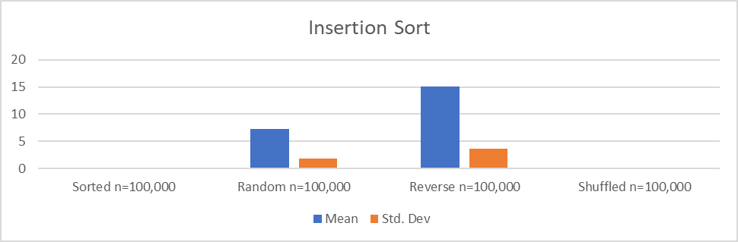
Next, Selection sort needs to be reviewed and examined on its average run times. As you can see with the graph below, Selection sort performed a lot more consistent than Insertion sort. Selection sort performed nearly identical in all cases except for sorting on a reverse array with the reverse array taking 14 seconds on average to complete with a miniscule standard deviation of .05 seconds while all the other sorts took on average 11.5 seconds also with little standard deviation ranging from .02-.05 seconds between runs. So, with those times in mind, it seems to be that Selection sort is more consistent with its run times but slower than Insertion sort in every aspect regardless of array type and size. 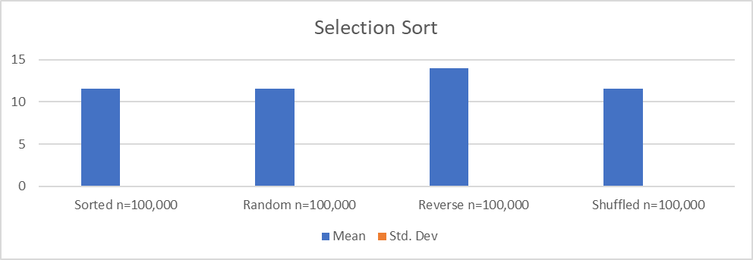
The last O(n^2) algorithm that needs to be examined is Bubble sort. Bubble sort by far was the worst performer compared to the other four sorting algorithms. In every case, Bubble sort was the slowest to complete with the random and reverse type arrays taking over 50 seconds to complete just one iteration with a standard deviation ranging from .02-3.8 seconds depending on the type of array being sorted. However, Bubble sort is not a complete waste, if the array is already sorted in ascending order, Bubble sort identifies that and finishes its iterations much more quickly than that of Selection sort. In conclusion, Bubble sort is a good algorithm to teach new computer science students to get this used to the idea of sorting algorithms but should not be used in general applications.
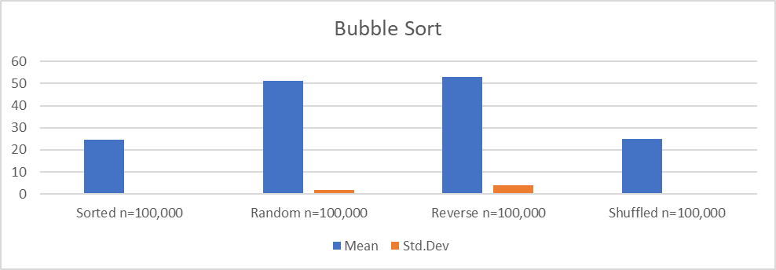
The first O(n log n) algorithm that needs to be analyzed is Quick sort. Quick sort was somewhat of a problem during the testing phase due to the way it was implemented. Due to the partition function selecting the last element in the array and not using a more advanced method such as using a median-of-three partition function, the recursion depth would not allow for large size tests to be made. So, for this comparison, all the results will be of size 10,000 instead of the normal 100,000. As you can see from the graph below, Quick sort performs the best on arrays filled with random values with a runtime of .01 seconds and a standard deviation of .002 seconds in the implementation used for this project. As you can see however, Quick sort hit many of its worst run time scenarios with an array already being sorted and with a 10% shuffle. In conclusion, if Quick sort was implemented using a more advanced partition function to cut down on recursion depth, the results would be faster and would allow for larger size testing.
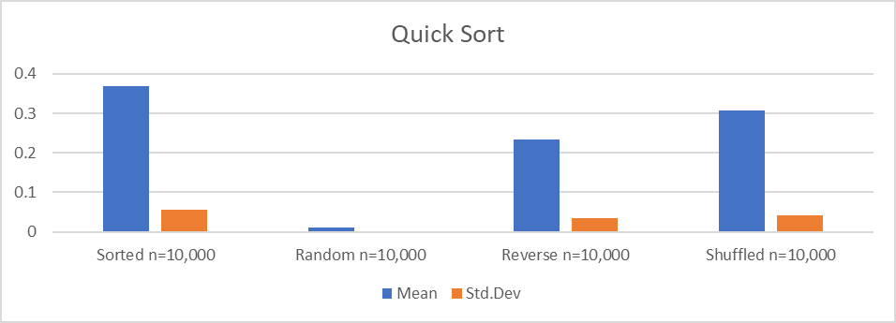
The last algorithm that needs to be reviewed is Merge sort. Merge sort was found to be very fast in all cases with miniscule variation amongst average run times and standard deviation. With an average of .02 seconds run times with a standard deviation of .0005 seconds this sorting algorithm is blazing fast and consistent across all types of arrays. In conclusion, using Merge sort it seemed not to matter much what type of array it was called on, Merge sort sorted the array very quickly and with very little deviation between each iteration as seen below. 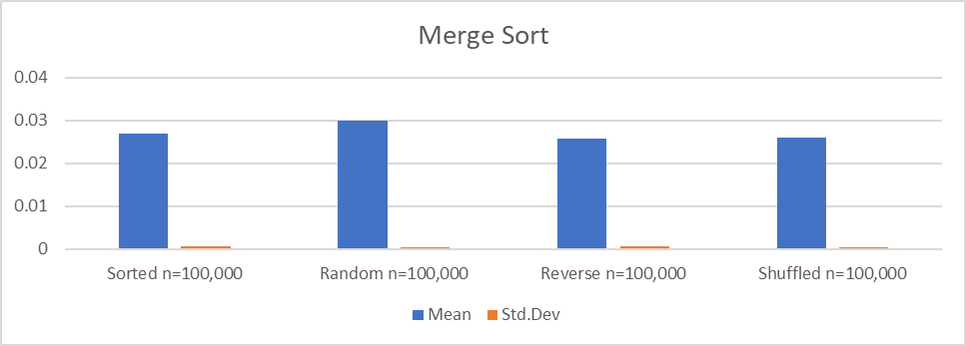
CONCLUSION

In conclusion, after testing five different sorting algorithms using four different types of arrays across multiple sizes, the only conclusions that can be taken away is that Merge sort in general is the superior sorting algorithm compared to the other four, especially since the way Quicksort was implemented, not using the median-of-three method. On average, it outperformed the other O(n^2) algorithms in all cases much to be expected due to its expected average run time of O(n log n). On the other side of the spectrum, it was found that in general Bubble sort was the worst performing algorithm with the slowest performance over the all the tests except for a select few. Insertion sort and Selection sort seemed to perform similarly enough to be interchangeable in most cases but with Insertion sort winning by small margins. Finally, Merge sort was discovered to be consistent across array types and faster than Quick sort in most scenarios. It is then the recommendation after all the testing that it is crucial that Quick sort be implemented using a more advanced partition method, so it could reduce recursion depth and then compete with Merge sort over many different types of arrays that need to be sorted.

REFERENCES

1 Cormen, T. H., Leiserson, C. E., Rivest, R. L., & Stein, C. (2014). Introduction to algorithms. Cambridge, MA: The MIT Press.
2 Weiss, M. A. (2014). Data structures and algorithm analysis in C. Boston: Pearson.
3 Wirth, N. (1976). Algorithms (plus) data structures = (equals) programs. ENGLEWOOD CLIFFS, NJ: PRENTICE HALL.

